Step 1 : Download & install 7-zip: https://7-zip.org/download.html
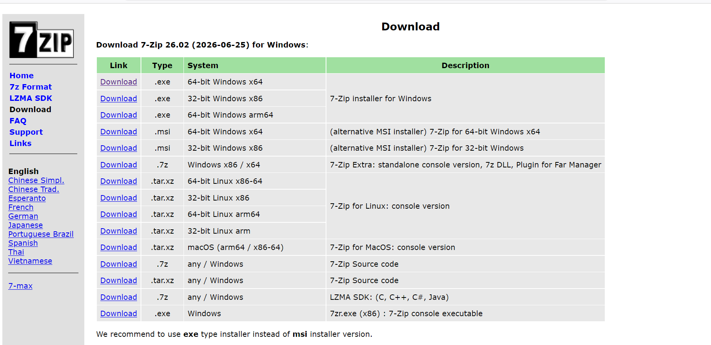
:Download first one.

